**STANDARD OPERATING PROCEDURE**

**On-site repair of HEMM**



**ODISHA MINING CORPORATION LTD.**

**KODINGAMALI BAUXITE MINE**

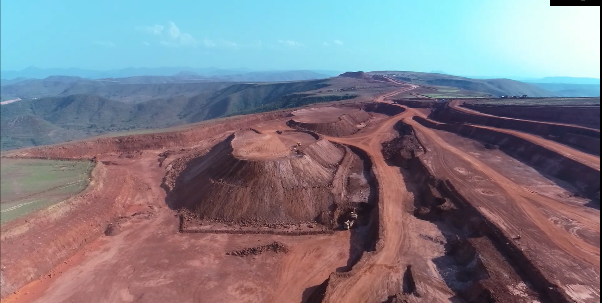

**Authorized By:**

**SOP for On-site repair of HEMM**

**Purpose:** This Safe Operating Procedure lays out guidelines for carrying out repairs on broken down HEMM/Mobile Machinery on a working face or a bench of an OC working, dump-yard or a stockyard or on haul roads (for reasons that it cannot be moved to a workshop/designated place where such repair & maintenance works are normally undertaken), so as to minimize potentiality of any injury to persons engaged in attending the machinery or any unplanned incident/accident which may have potentiality to cause damage to equipment or property, because of other HEMM operating in the area.

Possible scenarios during on-site repair of HEMM could be –

* Injury to persons due to other mobile HEMM/trucks/tippers operating in the area because of inadequate space between the breakdown HEMM & the operational area of other HEMM,
* Damage to the equipment being attended to due to uncontrolled movement of operational HEMM/tippers/trucks ramming in into the breakdown HEMM,
* Access to the breakdown HEMM being through operational area of other HEMM thus increasing risk to life and safety of person engaged in attending the HEMM or risk to the safety of service vehicles required to ply in and out.

This SOP lays down guidelines, also incorporating stipulations as prescribed by the Metalliferous Mines Regulations as well as directives as stipulated by circulars issued by DGMS from time to time, and shall be strictly complied with.

1. Should there be any breakdown in any HEMM or a mobile machinery, tipper-truck or truck, its parking brake shall be applied and its hazard-warning lights (blinking side-indicator lights) shall immediately be switched on to warn the operators of other HEMM/tipper-trucks, trucks or vehicles operating in the area.

* 1. In case of a wheeled trackless HEMM like wheeled-dozer/grader, pay-loader, tipper-truck or truck, the wheels of the breakdown HEMM shall additionally be choked with stoppers.
  2. An alarm may be raised through horn of the breakdown HEMM for supervisor’s attention or the supervisor may be contacted on mobile phone.
  3. Unless threatened for his life & safety (as in case of a fire), the operator of the breakdown HEMM shall remain seated inside the operator’s cabin and shall in no case get down or loiter around.

**Responsibility: Operator of breakdown HEMM**

1. The supervisor, on being informed or coming to know of such breakdown, shall ensure immediate cordoning off, of such HEMM/mobile machinery/tipper-truck by suitable flags or portable safety cones. In case of such breakdown occurring beyond day-light hours, area shall be cordoned off with fluorescent tape along with flashing lights mounted on small poles.

* 1. Adequate number of flags, portable safety cones, fluorescent tape and flashing lights shall be kept provided for the purpose at suitable places in the opencast workings, dump-yard(s), stock-yard(s) and at regular intervals along the mine’s haul road, including surface haul road.
  2. In case of tipper-trucks/trucks breaking down on haul-roads/transport road, traffic on the said section of the road shall be suspended and diverted to alternate route. Only in case there is adequate space to allow traffic movement, the tipper-truck/truck shall be cordoned off with suitable flags or portable safety cones or with fluorescent tape along with flashing lights mounted on small poles, and suitable barriers (may as well be dumping of OB) shall be put on either side of the break-down tipper-truck to prevent collision/tail-gating, before other tipper-trucks/trucks are allowed to ply on the said route.

**Responsibility: Concerned Supervisor, SO & Manager**

1. No repair on the breakdown HEMM/mobile machinery shall be undertaken unless by a system of work-permit, issued by the Official in-charge of the operations being conducted at the place of breakdown.
   1. A proper check-list and system of issuing of work permit shall be framed and implemented by the Mines Manager for the purpose, which shall depend on volume of traffic around the breakdown HEMM, distance between the breakdown HEMM and the operational area of other HEMM running in the vicinity, space required by the maintenance personnel including for using service equipment like crane, etc., access available to the breakdown HEMM, width & gradient of haul-road or transport road & width available for other tipper-trucks/trucks to ply (for breakdowns on haul-road/transport road), and likewise.
   2. A site-specific & job-specific plan shall be framed by the official responsible for the repair on breakdown HEMM, describing all systems, processes, procedures and safeguards to be undertaken to perform the work.

**Responsibility: Manager, Engineer (Mines)**

4. The operations on the face/bench or portion of the stock-yard or the OB dump-yard or on the section of the haul road in question **shall be preferably stopped** till the breakdown HEMM is attended and its repair is completed.

4.1 Before commencement of the examination or repair work on breakdown HEMM, the area required by maintenance personnel to attend to the breakdown shall be barricaded or cordoned off. The area may include space for stationing service equipment like cranes as well as service vehicles. Warning notices shall be posted to segregate the area.

**Responsibility: Manager, Engineer (Mines), Safety Officer &**

**Concerned Mine Officials and Supervisors**

5 **For on-site repairs to be undertaken on face/bench or in a stock-yard or OB dump-yard**:

5.1 **If operation of other HEMM** on the face/bench or portion of the stock-yard or the OB dump-yard in question **cannot be stopped** for any reason whatsoever, it shall be ensured that **adequate distance is kept maintained** between the area barricaded to attend the breakdown HEMM and operational area of other HEMM working on the face/bench or the stock-yard/OB dumping platform, as to allow repairs to be undertaken without any undue risk to life and safety of personnel engaged in such work.

5.2 **If such safe distance is not available** on the face/bench/stock-yard platform/ OB dumping platform, the operation of other HEMM on the face/bench or portion of the stock-yard or the OB dump-yard **shall be stopped before maintenance personnel are deployed on the breakdown HEMM and shall remain suspended so long the maintenance personnel are on site**.

5.3 **An independent/designated & barricaded access to maintenance personnel & their service equipment/vehicle(s)** **shall be provided** to enter/exit the area where breakdown HEMM is attended to, and such access shall be away from the operational area of other HEMM operating on the face/bench/stock-yard platform/ dumping platform. In case the access has to cross any stretch of operational area, such crossing shall be manned to regulate movement of service vehicles.

5.4 The access to enter/exit the area where breakdown HEMM is attended to shall be barricaded & warning notices shall be posted to segregate the access route.

5.5 **In case independent/designated/barricaded access cannot be provided**, the operation of other HEMM on the face/bench or portion of the stock-yard or the OB dump-yard **shall be stopped before maintenance personnel are deployed on the breakdown HEMM and shall remain suspended so long the maintenance personnel are on site**.

**Responsibility: Manager, Engineer (Mines), Safety Officer &**

**Concerned Mine Officials and Supervisors**

6. **For on-site repairs to be undertaken on Haul Road/Transport Road:**

6.1 **Repairs** on breakdown HEMM/tippers/trucks **shall not be taken on gradient**. All the wheels of the wheeled trackless equipment or of tippers/trucks shall be choked positively by stop-blocks before attending the breakdown machinery.

6.2 The area around the breakdown HEMM (includes the width of the road required by maintenance personnel to attend to the breakdown HEMM/truck/tipper) shall be barricaded and warning notices shall be posted to warn drivers of tippers/ trucks plying on the road.

6.3 **The remaining width of haul-road/transport-road**, excluding the protective berm/parapet or the drain on the high-wall side, as applicable, **should be adequate to allow tippers/trucks to pass through** without any risk to life and safety of personnel attending the breakdown, **failing which the traffic on the said section of the road shall be stopped** and shall remain suspended so long the repair is not completed.

6.4 Suitable barriers (may as well be dumping of OB) shall be put on either side of the break-down HEMM/tipper-truck to prevent to ensure that any out of control vehicle does not crash into the breakdown truck/tipper/HEMM or maintenance personnel attending it.

6.5 The traffic around the breakdown HEMM/tipper/truck shall be regulated by posting a competent person along with flags/glow-batons to ensure life and safety of maintenance personnel as well as of the moving traffic.

**Responsibility: Manager, Engineer (Mines), Safety Officer &**

**Concerned Mine Officials and Supervisors**

7 All work to attend the breakdown equipment shall be done in accordance to the procedures and safeguards framed and under personal supervision of a competent person.

7.1 All waste materials shall be removed from the site of repair after completion of the work.

**Responsibility: Engineer (Mines), Safety Officer &**

**Concerned maintenance personnel**

1. The Permit shall be signed off by the Official in-charge of the operations being conducted at the place of breakdown and Official undertaking the on-site repairs on completion of the work, before normal operations at the said place is allowed to resume.

**Responsibility: Engineer (Mines) & Concerned mine official**

**\*\*\*\*\*\*\*\*\*\*\*\*\*\*\*\*\*\*\*\*\*\*\*\*\*\*\*\*\*\***